Name: Year 7 – Liveability_________________
We have just looked at a number of places. Perhaps one of the things that the creator of the clip used to compare places, was how good they were to live in – their liveability.
Liveability: Start by answering these questions:
- If you could live anywhere in the world, where would it be? Name the country and the city.
________________________________________________________________________
- What is it about this place that makes you want to live there? __________________

________________________________________________________________________

- Where do you like to spend your time when you go out? (eg park, oval for sport, beach, dam, shops?)
_______________________________________________________________________
- What would you say are the most important features of a place that you would like to live in?
________________________________________________________________________
- Does the place you want to live have the features that are important to you?

________________________________________________________________________
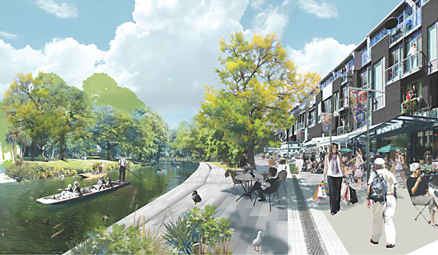
- Study the picture below and on the table over the page list the human made and natural features in the picture.

Natural features | Human made features

- List 5 reasons why this would be a ‘liveable’ place.

- Examine the picture below and list the human made and natural features in the table.
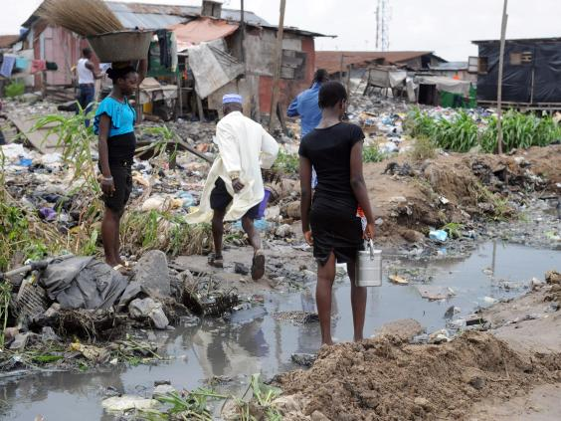
Natural features | Human made features
- List 5 reasons why this would NOT be a liveable place.

